**CAPSTONE PROJECT**

**EVENT MANAGEMENT SYSTEM**

**A PROJECT REPORT**

***Submitted by***

ROHITH[1922110434]

MOHAMMED SHURAIM M [192211316]

*Under the guidance of*

# DR.KATHIRAVAN

***in partial fulfillment for the completion of course CSA4399- INTERNET***

***PROGRAMMING FOR CLIENT SERVER COMPUTING***

**SIMATS ENGINEERING**

**THANDALAM**



**SEPTEMBER 2024**

## DECLARATION

We Rohith.M, Mohammed Shuraim.M**,** students of **Bachelor of Engineering in Computer Science**, Department of Computer Science and Engineering, Saveetha Institute of Medical and Technical Sciences, Saveetha University, Chennai, hereby declare that the work presented in this Capstone Project Work entitled **“EVENT MANAGEMENT SYSTEM”** is the outcome of our own bonafide work and is correct to the best of our knowledge and this work has been undertaken taking care of Engineering Ethics.

**M.ROHITH(192210434) Mohammed Shuraim.M** (192211316)

### BONAFIDECERTIFICATE

Certified that this project report titled **“EVENT MANAGEMENT SYSTEM**” is the bonafide work of “ROHITH.M **[192210434],** MOHAMMED SHURAIM.M**[192211316]”** Students of **Bachelor of Engineering in Computer Science,** Saveetha institute of Medical and Technical Sciences, Chennai, who carried out the project work under my supervision as a batch. Certified further, that to the best of my knowledge the work reported herein does not form any other project report .

**Date : Project supervisor Head of the Department**

**TABLE OF CONTENTS**

|  |  |
| --- | --- |
| **S.NO** | **TOPICS** |
| **1.** | **Introduction** |
| **2.** | **Abstract** |
| **3.** | **Problem Description**  Program to Build a simple software for Madarsi |
| **4.** | **Materials and Methods**  User Interface  Features |
| **5.** | **Approach/Module Description/Functionalities** |
| **6.** | **Implementation** Coding |
| **7.** | **Output** |
| **8.** | **Conclusion**  Future Enhancement  **References** |

#### INTRODUCTION

This report details the development of a comprehensive, web-based Event Management System aimed at optimizing the end-to-end process of event organization, planning, and execution. The system is specifically designed to simplify the management of key event-related tasks, including scheduling, guest list management, budget tracking, and overall event progress monitoring, all through a centralized online platform. This unified approach minimizes the complexity involved in managing multiple events and enhances the ability to oversee various logistical components efficiently.

The application is built with a strong focus on both functionality and user experience, ensuring a seamless and intuitive interaction for different types of users. Event administrators and planners are provided with a user-friendly interface that allows them to quickly create, modify, and manage events, while attendees or end-users can browse, view event details, and easily register for upcoming events. The system also enables real-time updates using JavaScript, ensuring that any changes to event details are instantly reflected for all users without the need for page reloads. Additionally, a responsive design ensures that the platform can be accessed from any device, including desktops, tablets, and smartphones, providing a consistent user experience across different screen sizes.

The Event Management System leverages modern web technologies to ensure a smooth, scalable, and reliable experience. The frontend is developed using HTML5, CSS3, and JavaScript to provide a dynamic and interactive interface, while ensuring smooth communication with backend services such as databases and event management logic. JavaScript handles real-time updates, enhancing user engagement by dynamically refreshing event data as it changes. The responsive design is achieved using CSS media queries, making the system adaptable to various screen sizes and devices, which is critical for event organizers who may need to manage events on the go.

One of the major advantages of the system is its automation of routine tasks such as sending notifications, managing registrations, and updating guest lists. This not only reduces the time spent on manual operations but also minimizes the risk of human error. Additionally, the platform offers a comprehensive dashboard for event organizers, providing a clear overview of important metrics such as the number of registered attendees, event budgets, and timelines, all of which contribute to more informed decision-making.

Furthermore, the system is built with scalability in mind, meaning it can accommodate a growing number of events and users without compromising performance. As the platform supports multiple event types, from small private gatherings to large public conferences, it offers the flexibility required for various use cases. The seamless integration of backend services ensures data consistency and integrity, allowing for smooth event management even as the system scales.

#### ABSTRACT

This report presents the development of a comprehensive web-based Event Management System designed to optimize the planning, organization, and execution of events. The system is engineered to streamline core event management functions, including event creation, scheduling, guest list management, budget tracking, and real-time updates. Leveraging modern web technologies such as HTML5, CSS3, and JavaScript, the platform delivers an intuitive user interface, offering a seamless experience for both administrators and attendees. Its responsive design ensures accessibility and consistent functionality across a wide range of devices.

By automating repetitive tasks and providing dynamic, real-time updates, the system significantly reduces manual effort, mitigates errors, and improves overall operational efficiency. The platform is built with scalability in mind, making it capable of managing events of varying sizes and complexities, from small gatherings to large-scale conferences. Through centralizing event data and enhancing collaboration among organizers and stakeholders, the system offers a robust, scalable, and user-friendly solution that enhances event coordination and execution.

**AIM:** To design and implement the website of event management system using HTML, JS, CSS.

**MATERIALS REQUIRED:** Hypertext Markup Language (HTML), Cascading Styles Sheet (CSS), Java Script (js), and developing environment like Visual Studio code is required.

**VS Code:** Visual Studio Code (VS Code) is a free, open-source code editor developed by Microsoft, designed to be lightweight yet powerful. It supports numerous programming languages and offers features such as syntax highlighting, integrated Git version control, and advanced debugging tools.

With its extensive marketplace, users can enhance functionality through a wide range of extensions and customize their development environment to fit their needs. VS Code also includes a built-in terminal and supports real-time collaboration through the Live Share extension, making it a versatile tool for developers.

#### EVENT MANAGEMENT SYSTEM;

#### An Event Management System (EMS) is a software application designed to streamline the planning, organization, and execution of events. It provides a centralized platform for managing various aspects of event coordination, including:

#### Event Creation and Scheduling: Allows users to create and schedule events, specifying details such as date, time, location, and description.

#### Guest Management: Facilitates the management of guest lists, including invitations, registrations, and tracking attendance.

#### Budget Tracking: Helps in monitoring and managing event budgets, including expenses and revenue.

#### Real-Time Updates: Provides real-time updates on event details, changes, and statuses to keep all stakeholders informed.

#### Event Promotion: May include features for promoting events, such as email invitations, social media integration, and online registration forms.

#### METHODOLOGY

#### For the development of the frontend of an Event Management System, Visual Studio Code (VS Code) is utilized as the primary code editor. The web pages are structured using HTML to define the layout and content, including sections for event creation, schedules, guest lists, and registration forms. CSS is employed to style the site, providing a visually appealing design, while Bootstrap is used to ensure a responsive layout that adapts seamlessly across various screen sizes and devices, enhancing mobile-friendliness.

#### JavaScript is integrated for client-side interactivity, enabling dynamic features such as real-time event updates, interactive calendars, and user registration functionalities. Additionally, JavaScript handles essential functionalities like form validation, event filtering, and sorting of event listings based on user preferences. This combination of technologies ensures a smooth and engaging user experience for managing and exploring events.

#### The frontend development incorporates responsive design principles to ensure that the web pages are accessible and functional across different devices, including desktops, tablets, and smartphones. To enhance the visual appeal and user experience, Google Fonts and Font Awesome are used to improve typography and iconography. Key interactive elements such as navigation bars, event carousels, and dynamic event maps are implemented to facilitate easy navigation and provide an intuitive interface for both event organizers and attendees.

#### IMPLEMENTATION

#### The implementation of the Event Management System's web pages begins with designing the overall layout using HTML. The site is organized into key sections, including a homepage for upcoming events, a detailed event creation page, and a dashboard for managing guest lists and budgets. HTML is used to structure these sections clearly, ensuring users can easily navigate and access various functionalities.

#### CSS and Bootstrap are employed to style the pages, providing a polished and responsive design. Bootstrap’s pre-built components, such as navigation bars, grids, and modals, are customized to fit the Event Management System’s theme, ensuring a consistent look across devices. CSS is used to refine visual elements, including fonts, colors, and spacing, enhancing the user interface and experience.

#### JavaScript is integrated to add dynamic functionality to the web pages. Features such as real-time event updates, interactive calendars, and form validation are implemented to improve user interactions. JavaScript handles tasks like filtering event listings based on criteria, managing guest registrations, and providing instant feedback on form submissions. Event listeners are utilized to manage user interactions, ensuring smooth functionality such as updating event details and processing registrations without requiring page reloads.

#### Additionally, JavaScript animations and transitions are incorporated to enhance the visual appeal and usability of the site. These include smooth transitions for form inputs and dynamic updates for event schedules. By leveraging JavaScript’s capabilities for DOM manipulation and event handling, the system provides an engaging and efficient user experience.

#### Throughout the implementation phase, Bootstrap’s responsive design principles ensure that the web pages adapt seamlessly to various screen sizes, from desktops to smartphones. Media queries are used to maintain a visually appealing layout across all devices, making the system accessible and user-friendly.

#### Overall, the integration of HTML, CSS, Bootstrap, and JavaScript results in a robust and interactive frontend for the Event Management System, delivering a streamlined platform for event planning, guest management, and real-time updates.

#### USER INTERFACE DESCRIPTION

#### User Interface Description for Event Management System

#### The User Interface (UI) of the Event Management System is meticulously designed to offer a streamlined and user-centric experience for event organizers and participants. The interface encompasses the following core components:

#### Homepage:

#### Objective: Acts as the central hub for the system, providing an overview of upcoming events and quick access to primary functionalities.

#### Features: Features a search bar for efficient event discovery, a calendar view highlighting key dates, and a carousel or grid layout showcasing featured or upcoming events with actionable links.

#### Event Creation and Management:

#### Event Creation Form: Facilitates the input of comprehensive event details including title, date, time, location, and description. Integrated validation mechanisms ensure data accuracy and completeness.

#### Event Dashboard: Offers a consolidated view of all events with functionality for editing, deleting, or accessing detailed information. Advanced filtering and sorting options enhance the management and oversight of scheduled events.

#### Guest Management:

#### Guest List Interface: Provides a dynamic list of invited and registered guests, including options for adding, editing, or removing entries. Includes RSVP tracking and status updates to streamline guest management.

#### Registration Forms: Features user-friendly forms for attendee registration, with real-time validation and confirmation messages to facilitate a smooth registration process.

#### Budget Tracking:

#### Budget Overview Section: Displays a comprehensive financial overview with visual aids such as charts and tables for tracking expenses and revenue. Provides insights into budget allocation and financial health.

#### Expense Management: Enables detailed input and categorization of expenses, along with payment tracking and financial reporting capabilities.

#### Real-Time Updates and Notifications:

#### Notification System: Delivers timely updates and notifications related to event changes, registrations, and important reminders. Notifications are prominently displayed on the dashboard and communicated via email alerts.

#### Dynamic Updates: Ensures that event details and statuses are updated in real-time, offering users the latest information without requiring manual page refreshes.

#### Event Promotion:

#### Promotion Tools: Integrates functionalities for event promotion, including customizable email invitations, social media sharing options, and online registration forms. Provides templates and design options for creating effective promotional content.

#### Analytics and Reporting: Offers analytical tools to monitor event engagement and effectiveness, generating actionable insights through detailed reports and metrics.

#### Responsive Design:

#### Accessibility and Usability: The UI is designed with responsiveness in mind, ensuring optimal functionality and visual appeal across various devices, including desktops, tablets, and smartphones.

#### Navigation and Layout: Features intuitive navigation elements such as a fixed header with menu options, breadcrumb trails, and well-structured links to enhance user experience and accessibility.

#### MODULE DESCRIPTION

##### Home Module

##### The Home Module serves as the primary landing page for the Event Management System, providing users with an overview of upcoming and past events. This module is designed with a visually appealing banner showcasing featured or highlighted events, encouraging users to explore further. Below the banner, a section displays upcoming events in a card-based layout, each card presenting key details such as the event title, date, location, and a short description. Users can click on these cards to view more detailed information or register for the event. The module emphasizes a user-friendly and welcoming interface, guiding users to quickly access essential event information and take action, such as signing up for an event or viewing event updates.

##### Event Creation Module

##### The Event Creation Module enables administrators and event planners to create and manage events efficiently. This module features a form-based interface, allowing users to input event details, including the event name, date, time, location, and description. The form is structured with HTML, styled using CSS for an attractive and functional layout, and includes JavaScript to validate form entries and ensure accurate data submission. Once submitted, the event details are stored in the system’s backend, where they can be edited or updated if needed. The module allows users to create multiple events while ensuring that all necessary information is captured, providing a seamless process for event planning.

##### Guest Management Module

##### The Guest Management Module is designed to streamline the management of event attendees. This module allows administrators to manage guest lists by adding, removing, or modifying guest information. It features tools for sending invitations, tracking RSVPs, and monitoring attendance status. HTML is used to structure the guest list interface, while JavaScript enables real-time updates and interaction with the list. Administrators can easily view which guests have confirmed or declined attendance, and updates are reflected dynamically without requiring page reloads..

##### Budget Tracking Module

##### The Budget Tracking Module helps event organizers monitor and control event finances. It provides a dashboard that allows users to input and track expenses and income associated with an event. The module displays key financial data, such as the overall budget, total expenses, and remaining balance. JavaScript is used to calculate expenses in real-time, while CSS is applied to visually differentiate various expense categories, helping users easily manage and adjust their budgets. This module also generates alerts when spending approaches the predefined budget limit, ensuring that event organizers stay within financial constraints.

##### Event Listing and Promotion Module

##### The Event Listing and Promotion Module showcases a comprehensive list of all upcoming and past events. Events are displayed in an interactive, card-based layout that includes essential details such as the event date, location, and description. Users can search for events using filters based on categories like event type, date, or location, making it easy to find specific events of interest. The module also includes promotional features like social media sharing options and integrated email invitations, allowing administrators to effectively market events to a wider audience. This module ensures that all stakeholders, including attendees and event planners, have access to real-time event information and promotional tools.

##### Review Submission Module

#### The Review Submission module in the Event Management System allows users to provide feedback and rate events they have attended. The module features a simple form where users can input the event name, select a rating (from 1 to 5 stars), and provide written comments regarding their experience. Once submitted, the review is dynamically added to the event’s page, enhancing the system with valuable user-generated content. The process is user-friendly, with form validation to ensure all required fields are completed before submission. This module improves the overall interactivity of the platform and helps future attendees make informed decisions.

#### FUNCTIONALITIES

The Event Management System offers a comprehensive suite of functionalities designed to streamline the event planning process and enhance user engagement. It allows administrators to create and manage events, with features like detailed event descriptions, schedules, and location information. Each event is presented with relevant details such as the title, date, time, venue, and expected number of guests, ensuring clarity for both organizers and attendees. The system includes a responsive event listing page, allowing users to browse upcoming events, register, and receive notifications about changes or updates.

The platform integrates dynamic forms for event creation and guest management, enabling users to submit details and registrations in real-time. An interactive calendar feature is available, allowing users to view all scheduled events and filter by date or category for easier navigation. Users can also track guest lists and attendance, ensuring a streamlined guest management process. Additionally, the platform includes budget tracking functionality, allowing event organizers to monitor expenses, revenue, and overall financial health of the event.

To further enhance the user experience, the system includes interactive elements such as live updates on event status, notifications, and reminders via email or SMS. Event promotion is facilitated through built-in social media sharing tools and online registration forms. The platform is fully responsive, designed to function seamlessly across various devices and screen sizes, ensuring that users can access event details from desktops, tablets, or smartphones.

Additionally, the user interface is designed for ease of use, featuring intuitive navigation and a clear layout that simplifies the process of event creation and management. The event registration process is integrated with real-time validation, providing instant feedback and ensuring that user input is accurate and complete. The combination of these functionalities ensures that event organizers can efficiently plan and execute events, while attendees have a smooth and interactive experience.

#### PROCESS

##### ➔ HTML

* index.html
* Chennai-details.html
* stay-details.html
* **CSS**
* styles.css

##### ➔ Javascript

➔ script.js

**Program:**

**LOGIN PAGE**

<!DOCTYPE html>

<html lang="en">

<head>

    <meta charset="UTF-8">

    <meta name="viewport" content="width=device-width, initial-scale=1.0">

    <title>Login - Event Management System</title>

    <style>

        body {

            font-family: Arial, sans-serif;

            background-color: #f4f4f4;

            display: flex;

            justify-content: center;

            align-items: center;

            height: 100vh;

            margin: 0;

            background-image: url('https://wallpapercave.com/wp/wp2349396.jpg'); /* Background image link */

            background-size: cover;

            background-position: center;

        }

        .login-container {

            background: rgba(255, 255, 255, 0.9);

            padding: 40px;

            border-radius: 12px;

            box-shadow: 0 0 15px rgba(0,0,0,0.2);

            width: 90%;

            max-width: 400px;

            text-align: center;

        }

        .login-container img {

            width: 100px;

            height: 100px;

            margin-bottom: 20px;

            border-radius: 50%;

        }

        h2 {

            margin-bottom: 20px;

        }

        label {

            display: block;

            text-align: left;

            margin-bottom: 8px;

            font-weight: bold;

        }

        input[type="text"], input[type="password"] {

            width: 100%;

            padding: 10px;

            margin-bottom: 15px;

            border: 1px solid #ddd;

            border-radius: 4px;

        }

        input[type="submit"] {

            width: 100%;

            padding: 10px;

            border: none;

            border-radius: 4px;

            background-color: #007bff;

            color: white;

            font-size: 16px;

            cursor: pointer;

            margin-top: 10px;

        }

        input[type="submit"]:hover {

            background-color: #0056b3;

        }

        .signup-link {

            margin-top: 15px;

            font-size: 14px;

        }

        .signup-link a {

            color: #007bff;

            text-decoration: none;

        }

        .signup-link a:hover {

            text-decoration: underline;

        }

        .error-message {

            color: red;

            margin-top: 10px;

        }

    </style>

</head>

<body>

    <div class="login-container">

        <img src="https://encrypted-tbn0.gstatic.com/images?q=tbn:ANd9GcRLig1H5cfDbpeQEeeMn1zGuHLRJZ87Y-GT2w&s" alt="User Image">

        <h2>Login</h2>

        <form id="loginForm">

            <label for="username">Username:</label>

            <input type="text" id="username" name="username" required>

            <label for="password">Password:</label>

            <input type="password" id="password" name="password" required>

            <input type="submit" value="Login">

        </form>

        <div class="signup-link">

            Don't have an account? <a href="signup page.html">Sign up here</a>

        </div>

        <div id="error-message" class="error-message"></div>

    </div>

    <script>

        document.getElementById('loginForm').addEventListener('submit', function(event) {

            event.preventDefault(); // Prevent the default form submission

            const username = document.getElementById('username').value;

            const password = document.getElementById('password').value;

            const errorMessage = document.getElementById('error-message');

            const storedUsername = localStorage.getItem('username');

            const storedPassword = localStorage.getItem('password');

            if (username === storedUsername && password === storedPassword) {

                window.location.href = 'admin home page.html';

            } else {

                errorMessage.textContent = 'Invalid username or password.';

            }

        });

    </script>

</body>

</html>

**HOMEPAGE**

<!DOCTYPE html>

<html lang="en">

<head>

    <meta charset="UTF-8">

    <meta name="viewport" content="width=device-width, initial-scale=1.0">

    <meta name="description" content="Event Management System for organizing and managing events seamlessly.">

    <meta name="keywords" content="Event Management, Event Planning, Event Registration">

    <title>Home - Event Management System</title>

    <style>

        body {

            font-family: Arial, sans-serif;

            margin: 0;

            padding: 0;

            background-color: #f4f4f4;

            background-image: url('https://eventbrite-s3.s3.amazonaws.com/marketing/landingpages/assets/2023/organizer/a_organizer_event--creator-eventbrite-.jpeg');

            background-size: cover;

            background-position: center;

        }

        .container {

            display: flex;

            flex-direction: column;

            align-items: center;

            margin: 20px;

        }

        header {

            background: rgba(255, 255, 255, 0.8);

            padding: 20px;

            border-radius: 8px;

            box-shadow: 0 0 10px rgba(0,0,0,0.1);

            width: 100%;

            max-width: 1200px;

            text-align: center;

            position: relative;

        }

        header img {

            width: 100px;

            height: 100px;

            border-radius: 50%;

            object-fit: cover;

            border: 2px solid #007bff;

            margin-bottom: 10px;

        }

        header h1 {

            margin: 10px 0;

            color: #333;

        }

        header h2 {

            margin: 10px 0;

            color: #333;

        }

        .menu {

            position: absolute;

            top: 30px;

            right: 30px;

            font-size: 24px;

            color: #007bff;

            cursor: pointer;

            z-index: 1001;

        }

        .menu-content {

            display: none;

            position: absolute;

            top: 60px;

            right: 30px;

            background: rgba(255, 255, 255, 0.9);

            border-radius: 8px;

            box-shadow: 0 0 10px rgba(0,0,0,0.1);

            z-index: 1000;

        }

        .menu-content a {

            display: block;

            text-decoration: none;

            color: #007bff;

            padding: 10px;

            border-bottom: 1px solid #ddd;

            text-align: center;

        }

        .menu-content a:last-child {

            border-bottom: none;

        }

        .menu-content a:hover {

            background-color: #f4f4f4;

        }

        .content {

            background: rgba(255, 255, 255, 0.8);

            padding: 20px;

            border-radius: 8px;

            box-shadow: 0 0 10px rgba(0,0,0,0.1);

            width: 100%;

            max-width: 1200px;

            margin-top: 20px;

            text-align: center;

        }

        .content h3 {

            color: #333;

            margin-bottom: 20px;

        }

        .image-gallery {

            display: grid;

            grid-template-columns: repeat(3, 1fr);

            gap: 20px;

            max-width: 1200px;

            width: 100%;

            margin-top: 20px;

        }

        .image-box {

            border: 2px solid #000;

            border-radius: 8px;

            overflow: hidden;

            position: relative;

        }

        .image-box img {

            width: 100%;

            height: 200px;

            object-fit: cover;

        }

        .image-box .caption {

            padding: 10px;

            background: #fff;

            border-top: 2px solid #000;

            text-align: center;

            color: #333;

        }

        footer {

            margin-top: 20px;

            color: #fff;

            text-align: center;

            font-size: 14px;

        }

        .notification {

            display: none;

        }

    </style>

    <script>

        function toggleMenu() {

            const menuContent = document.getElementById('menu-content');

            menuContent.style.display = menuContent.style.display === 'block' ? 'none' : 'block';

        }

        document.addEventListener('click', function(event) {

            const menuContent = document.getElementById('menu-content');

            const menu = document.querySelector('.menu');

            if (!menu.contains(event.target) && !menuContent.contains(event.target)) {

                menuContent.style.display = 'none';

            }

        });

        document.querySelectorAll('.menu-content a').forEach(link => {

            link.addEventListener('click', () => {

                document.getElementById('menu-content').style.display = 'none';

            });

        });

    </script>

</head>

<body>

    <div class="container">

        <header>

            <img src="https://www.catholicsingles.com/wp-content/uploads/2020/06/blog-header-3.png" alt="User Avatar">

            <h1>Event Management System</h1>

            <div class="menu" onclick="toggleMenu()">☰</div>

            <div id="menu-content" class="menu-content">

                <a href="profile.html">Profile</a>

                <a href="event registration.html">Create Event</a>

                <a href="events list.html">View Registrations</a>

                <a href="settings.html">Update Settings</a>

                <a href="generate reports.html">Generate Reports</a>

                <a href="login.html">Sign Out</a>

            </div>

        </header>

        <div class="content">

            <h3>Event Management System</h3>

            <p>Our Event Management System is designed to simplify the process of planning and executing events of all sizes. With an intuitive user interface and powerful features, it caters to a diverse range of events, from intimate gatherings to large-scale conferences. Key functionalities include:</p>

            <ul>

                <li><strong>Event Scheduling:</strong> Easily schedule events, set dates, and manage time slots. Our system provides automated reminders and notifications to ensure no detail is overlooked.</li>

                <li><strong>Registration Management:</strong> Customize registration forms to collect attendee information and manage ticket sales. Track registrations in real-time and generate reports on attendee demographics.</li>

                <li><strong>Resource Allocation:</strong> Efficiently manage event resources such as venues, equipment, and staff. Allocate resources based on event needs and availability.</li>

                <li><strong>Event Promotion:</strong> Use built-in marketing tools to promote your events. Create and send invitations, manage RSVPs, and integrate with social media platforms.</li>

                <li><strong>Financial Tracking:</strong> Keep track of event budgets, expenses, and revenue. Generate financial reports to assess the profitability of your events.</li>

                <li><strong>Customizable Templates:</strong> Utilize a variety of event templates for different types of events, from corporate seminars to weddings and parties. Customize them to fit your specific needs.</li>

                <li><strong>Reporting and Analytics:</strong> Access detailed analytics and reports on event performance. Measure key metrics like attendance rates, revenue, and attendee satisfaction.</li>

                <li><strong>24/7 Support:</strong> Our dedicated support team is available around the clock to assist with any issues or questions you may have. We’re here to ensure your events are a success.</li>

            </ul>

            <p>Whether you are organizing a corporate meeting, a charity fundraiser, or a social gathering, our system provides the tools and flexibility needed to ensure a smooth and successful event.</p>

            <div class="image-gallery">

                <a href="birthday party.html" class="image-box">

                    <img src="https://media.istockphoto.com/id/1074986054/photo/group-of-children-at-birthday-party-at-home.jpg?s=612x612&w=0&k=20&c=ggIzZGu_Ti3Evr5ebSOwoDfEPgU2DON3lXWKhRFUEuU=" alt="Children at a birthday party">

                    <div class="caption">Birthday Party</div>

                </a>

                <a href="concerts page.html" class="image-box">

                    <img src="https://encrypted-tbn0.gstatic.com/images?q=tbn:ANd9GcRqqNhH_hKQ24uJMKILKo70-lkTTUyQLtHrAQ&s" alt="Concert Event Management">

                    <div class="caption">Concert Event Management</div>

                </a>

                <a href="conferece page.html" class="image-box">

                    <img src="https://encrypted-tbn0.gstatic.com/images?q=tbn:ANd9GcSPRx0-FQ6E1jjHKzTC83b9I5A3dto6weL_hA&s" alt="Conference">

                    <div class="caption">Conference</div>

                </a>

                <a href="wedding page.html" class="image-box">

                    <img src="https://encrypted-tbn0.gstatic.com/images?q=tbn:ANd9GcSKT676tR25abjGI_jFLkln8xjDQW-t78KtJg&s" alt="Wedding">

                    <div class="caption">Wedding</div>

                </a>

                <a href="party page.html" class="image-box">

                    <img src="https://thumbs.dreamstime.com/b/fans-enjoying-party-vibes-stage-lights-crowd-audience-hands-raised-music-festival-young-cheerful-active-151818041.jpg" alt="Party">

                    <div class="caption">Party</div>

                </a>

                <a href="product launches.html" class="image-box">

                    <img src="https://www.shutterstock.com/image-photo/new-product-business-development-concept-260nw-2336599687.jpg" alt="Product Launch Events">

                    <div class="caption">Product Launches</div>

                </a>

            </div>

        </div>

        <footer>

            &copy; 2024 Event Management System. All rights reserved.

        </footer>

    </div>

</body>

</html>

#### FUTURE SCOPE The future scope of the Event Management System for web development includes the integration of advanced features to further enhance user experience and functionality. Future developments could involve incorporating artificial intelligence to provide personalized event recommendations based on user preferences, historical data, and previous interactions. Additionally, integrating real-time seat booking and availability checks would allow users to reserve spots directly through the system, streamlining the process and improving convenience. Expanding the platform to include multilingual support could broaden accessibility for global users. Moreover, incorporating user-generated content such as event reviews, photos, or feedback, and enhancing data analytics capabilities could provide deeper insights into attendee behavior and preferences, enabling continuous improvement and customization of services.

#### OUTPUT

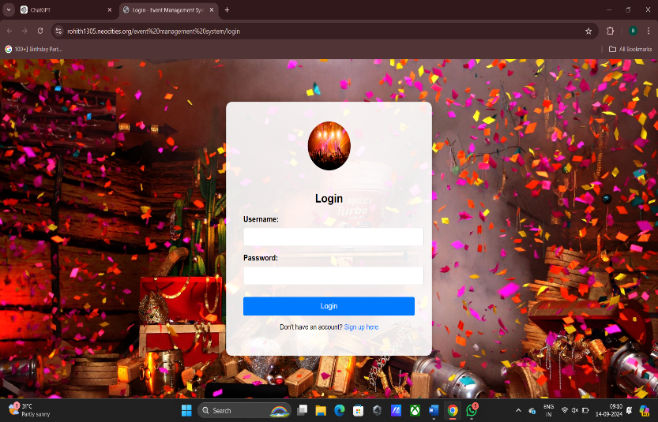

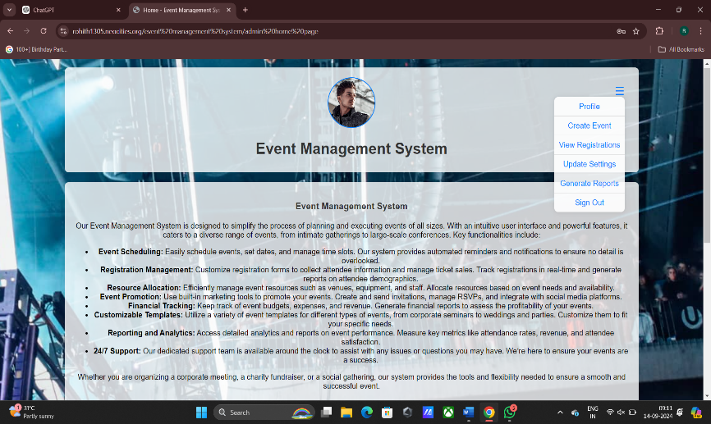

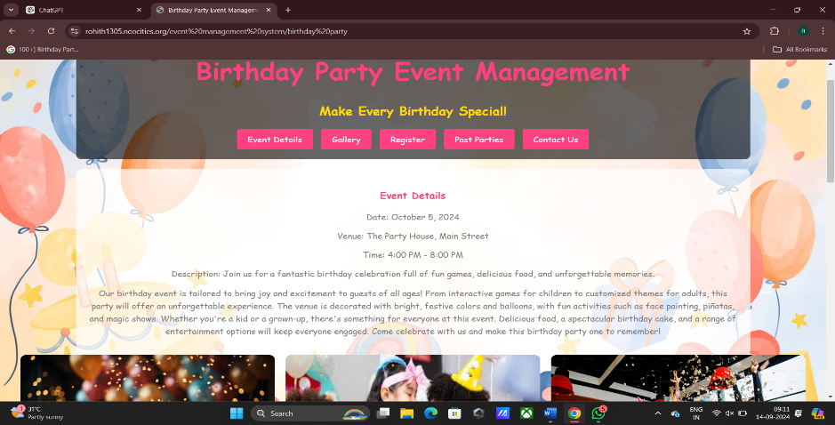

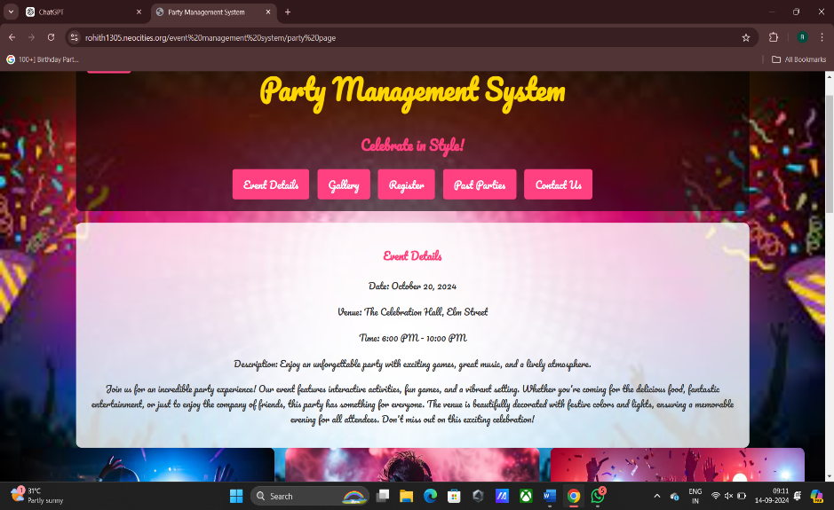

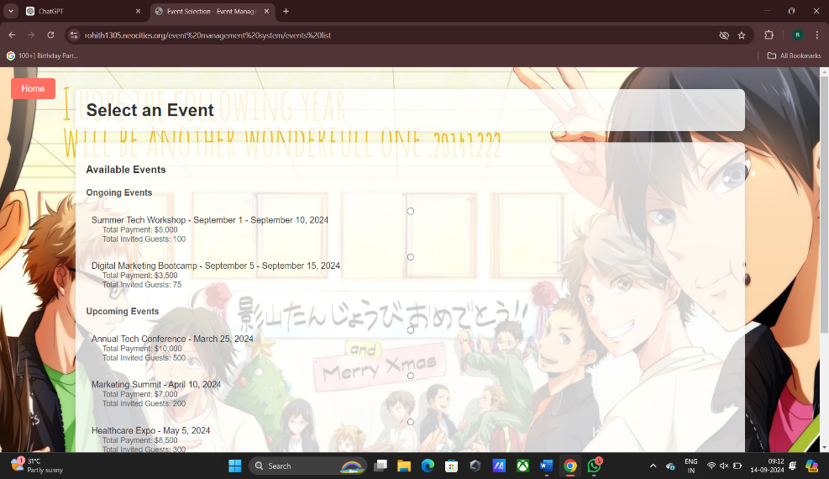

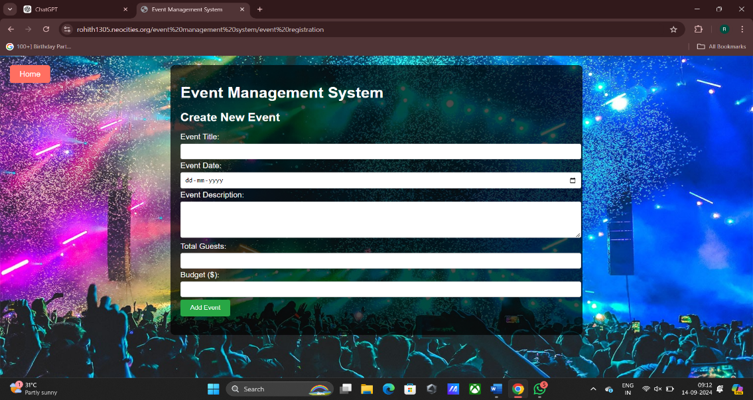

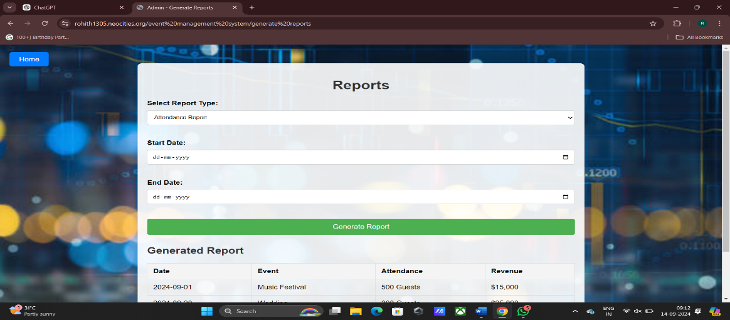

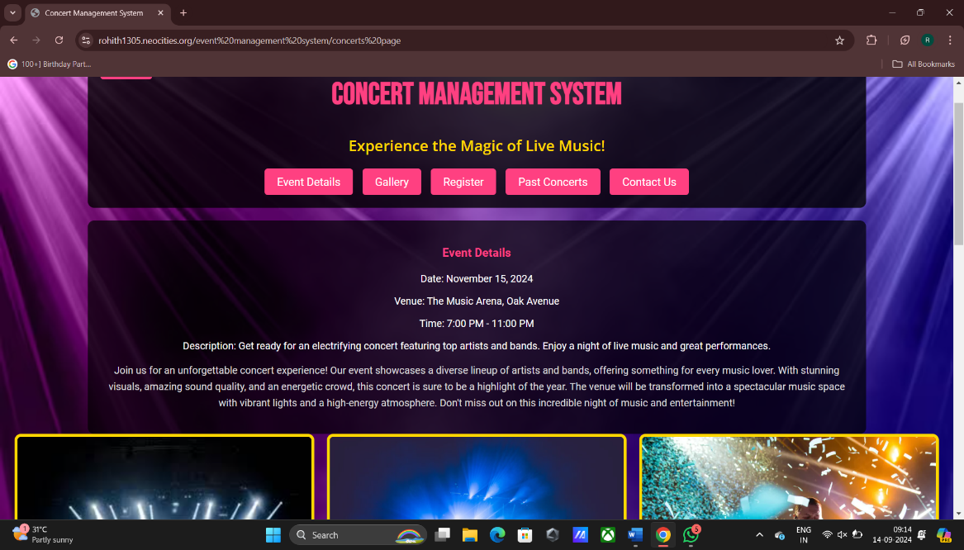

**Conclusion**

#### In conclusion, the Event Management System is a comprehensive and user-friendly solution designed to streamline the planning, organization, and management of events. By leveraging modern web technologies such as HTML, CSS, JavaScript, and server-side scripting, the system effectively addresses the complex needs of event coordinators, clients, and attendees. Key features such as dynamic event creation, real-time updates, and a responsive interface ensure accessibility across devices and enhance the user experience.

#### This project demonstrates the successful implementation of core web development principles, including modular design, efficient database management, and dynamic user interaction through AJAX and JavaScript. The system not only simplifies event management tasks but also provides valuable insights through data reporting and tracking.

#### Overall, this project showcases the importance of web-based solutions in automating event management processes, reducing manual effort, and ensuring seamless coordination, making it a valuable tool for any event-related enterprise.

#### REFERENCES

**1**. Bibi, M. (2013). *Event Management System* (Doctoral dissertation, Quaid I Azam University).

2. Jones, M. (2017). *Sustainable event management: A practical guide*. Routledge.

3. Mercy, K., Salyer, S. J., Mankga, C., Hedberg, C., Zondo, P., & Kebede, Y. (2024). Establishing an wearly warning event management system at Africa CDC. *PLOS Digital Health*, *3*(7), e0000546.

4. Bezas, K., & Filippidou, F. (2023). Comparative analysis of open source security information & event management systems (SIEMs). *The Indonesian Journal of Computer Science*, *12*(2), 443-468.

**33**